LAND-BASED CROP GROWTH SIMULATION AND PREDICTION USING MACHINE LEARNING

A PROJECT REVIEW REPORT 3

Submitted by

KARTHIK K (412722205022)

INBATAMILAN P (412722205015)

KANNAN R (412722205021)

SANTHOSH J (412722205039)

in partial fulfilment for the award of the degree

of

BACHELOR OF TECHNOLOGY
in
INFORMATION TECHNOLOGY

TAGORE ENGINEERING COLLEGE
RATHINAMANGALAM,
CHENNAI 600 127

ANNA UNIVERSITY: CHENNAI 600 025
JAN 2026
ABSTRACT :

Agriculture is essential for food security and economic stability, but farmers face challenges in crop selection, soil management, and early disease detection. This project proposes a Land-Based Crop Growth Simulation and Prediction System using Machine Learning, which predicts suitable crops based on soil type, nutrient levels, pH, climate, and land area. The system also includes disease prediction and fertilizer recommendation to improve crop health and yield. A key feature is the crop growth simulation module that visually represents the entire cultivation process from soil preparation to harvesting, helping farmers understand crop stages virtually. By integrating all these features into a single platform, the system supports informed decision-making, reduces crop failure, and promotes sustainable smart farming.

LITERATURE SURVEY

  - TITLE: Crop Prediction Using Machine Learning
AUTHOR:Ramesh et al., 2018, IEEE
YEAR: 2018, IEEE

Description:

This research paper by Ramesh et al. (2018) presents a machine learning-based approach for predicting suitable crops based on environmental and soil parameters. The main objective of the study is to support farmers in selecting the most appropriate crop for cultivation by analyzing historical agricultural data. The authors emphasize that traditional crop selection methods rely heavily on farmers’ experience and regional practices, which may not always lead to optimal productivity. Hence, an intelligent prediction model is proposed to improve decision-making in agriculture.
The system uses key input parameters such as soil type, temperature, rainfall, humidity, and other climatic factors. These attributes are collected from agricultural datasets and preprocessed to remove inconsistencies and missing values. The authors implemented classification algorithms including Decision Tree and Naïve Bayes to build predictive models. Decision Tree helps in creating rule-based crop selection paths, while Naïve Bayes provides probabilistic classification based on feature likelihood. The combination of these algorithms enables the system to predict the most suitable crop for a given set of environmental conditions.
Experimental results showed that the model could successfully recommend crops for specific soil and weather conditions. The study demonstrates the usefulness of machine learning in agriculture by automating crop selection and reducing dependency on manual decision-making. However, the authors reported certain limitations. The prediction accuracy decreases when the dataset becomes large or contains complex non-linear relationships. Additionally, Naïve Bayes assumes feature independence, which may not hold true in agricultural datasets where environmental factors are often interrelated.
Overall, this research contributes to the field of smart agriculture by introducing a data-driven crop prediction framework. It highlights the potential of machine learning algorithms to improve crop productivity and resource utilization. The study also suggests that future work can involve advanced algorithms such as Random Forest or Neural Networks to handle large-scale and non-linear agricultural data more effectively. This paper provides a foundational reference for the proposed smart farming system, as it demonstrates how environmental data can be used to predict suitable crops using machine learning techniques.

2.2 TITLE: Patel et al., 2019, Springe
AUTHOR: Soil-Based Crop Recommendation System
YEAR: 2019

Description:
The proposed system collects soil parameters such as nitrogen, phosphorus, potassium levels, pH value, and moisture content, along with rainfall data of a region. These features are used as input to a machine learning model based on the K-Nearest Neighbors (KNN) algorithm. KNN is a supervised learning method that classifies data points by comparing them with similar instances in the training dataset. In this context, the algorithm identifies crops that were successfully grown under similar soil and rainfall conditions and recommends them to farmers.
The study demonstrates that the soil-based recommendation approach can effectively guide farmers toward selecting crops that match their land characteristics. The system is capable of suggesting multiple crop options, thereby supporting decision-making and risk reduction. The authors report that the model achieved satisfactory recommendation accuracy when tested with agricultural datasets. The approach is particularly beneficial for precision agriculture and sustainable farming practices, as it encourages optimal use of soil nutrients and water resources.
Despite its advantages, the research identifies certain limitations. The KNN algorithm is sensitive to noisy or incomplete data, which can affect recommendation accuracy. Additionally, the computational complexity increases with larger datasets because KNN requires comparison with all training samples during prediction. This makes the system slower when handling large-scale agricultural data. The authors suggest that future work may include hybrid models or optimization techniques to improve scalability and robustness.
In conclusion, Patel et al. provide an effective soil-centric crop recommendation framework that integrates soil analysis with machine learning. The study is relevant to smart farming applications because it demonstrates how soil nutrient data can be directly used for crop decision support. This research supports the importance of integrating soil parameters in crop recommendation systems and serves as a key reference for developing intelligent agricultural advisory platforms.

2.3 TITLE: Precision Agriculture Using Machine Learning
AUTHOR: Singh et al.,
YEAR: 2023

Description:
This Singh et al. (2023) proposed a precision agriculture framework that utilizes advanced machine learning techniques to improve crop yield through data-driven prediction. The primary objective of the study is to enhance agricultural productivity by analyzing multiple environmental and soil-related parameters and providing accurate crop recommendations. The authors highlight that modern agriculture requires intelligent systems capable of processing large volumes of data to support efficient decision-making and resource management.
The proposed system collects agricultural data such as soil nutrients, temperature, humidity, rainfall, and historical crop yield records. After preprocessing and cleaning the dataset, machine learning algorithms including Random Forest and XGBoost are applied for predictive modeling. Random Forest is an ensemble learning method that builds multiple decision trees and combines their outputs to improve accuracy and reduce overfitting. XGBoost (Extreme Gradient Boosting) is a powerful boosting algorithm known for its high performance and ability to handle complex, non-linear relationships in large datasets. These algorithms enable the system to generate more reliable crop yield predictions compared to traditional single-model approaches.
The experimental results demonstrate that ensemble methods provide higher prediction accuracy and better generalization capability. The study shows that data-driven models can assist farmers in selecting suitable crops and optimizing agricultural inputs such as fertilizers and irrigation. By leveraging predictive analytics, the system supports precision farming practices and promotes efficient use of resources.
However, the research identifies certain limitations. Although the model achieves strong prediction performance, it does not include visualization tools for crop growth analysis or simulation features to demonstrate long-term yield trends. The absence of interactive visualization reduces the system’s usability for farmers who may benefit from graphical insights. The authors suggest that future improvements could integrate real-time monitoring, visualization dashboards, and IoT-based data collection for enhanced decision support.
In conclusion, Singh et al. provide a robust machine learning-based precision agriculture model that improves crop prediction accuracy using ensemble techniques. The study strengthens the application of advanced algorithms in smart farming systems and serves as an important reference for developing intelligent agricultural decision support platforms.

SYSTEM ANALYSIS

3.1 EXISTING SYSTEM
The current agricultural decision-making practices are largely based on traditional farming knowledge, farmer experience, and seasonal observations rather than scientific data analysis. In most regions, crop selection is performed without systematic evaluation of soil nutrients, climatic conditions, or historical yield data, which often leads to sub-optimal productivity. Farmers typically rely on generalized recommendations and conventional practices that do not account for field-specific variations in soil fertility and environmental factors.
Crop disease identification in the existing system is mainly carried out through manual visual inspection of plants. This approach requires expertise and often detects diseases only after visible symptoms appear, making early prevention difficult. Similarly, fertilizer application is usually determined by broad agricultural guidelines instead of precise soil testing, resulting in either excessive or insufficient nutrient usage. Such practices not only reduce crop yield but also affect soil health over time.
Furthermore, there is no integrated technological platform that provides visualization of crop growth stages or land-based simulation of farming outcomes. Farmers lack access to predictive insights, growth monitoring tools, and decision-support systems that could help them understand the complete crop lifecycle. As a result, agricultural planning remains largely manual, fragmented, and dependent on experience rather than data-driven intelligence.

Disadvantages
    - Manual Decision-Making: Farming decisions based on experience and guesswork reduce operational efficiency and consistency.
    - Low Prediction Accuracy: Absence of data-driven crop selection leads to unsuitable crop choices and poor yield outcomes.

    - Delayed Disease Detection: Manual visual inspection identifies diseases late, causing significant crop damage and loss.
    - Lack of Integrated Systems: Absence of visualization and simulation tools makes it difficult to monitor crop growth and lifecycle effectively.

3.2 PROPOSED SYSTEM
The proposed system is a smart land-based agriculture platform that integrates machine learning and data analytics to support intelligent farming decisions. Unlike traditional methods that rely on experience, the system uses scientific analysis of soil nutrients, pH value, climatic conditions, and land characteristics to recommend the most suitable crops for cultivation. By processing agricultural datasets and environmental parameters, the system provides accurate crop prediction tailored to specific field conditions, thereby improving productivity and resource utilization.
In addition to crop recommendation, the proposed system incorporates image-based crop disease detection to identify plant diseases at an early stage. Farmers can capture leaf images, and the system analyzes visual symptoms using machine learning models to detect potential diseases before they spread widely. The platform also recommends appropriate fertilizers based on soil deficiencies and crop requirements, ensuring balanced nutrient application and improved soil health.
A key feature of the proposed system is its integrated visualization module, which simulates crop growth stages and cultivation processes in a single unified interface. This simulation helps farmers understand the complete crop lifecycle, from sowing to harvesting, enabling better planning and monitoring. By combining prediction, disease detection, fertilizer guidance, and growth visualization, the system provides a comprehensive decision-support environment for modern precision agriculture.
Advantages

    - Improved Crop Selection: Data-driven crop prediction increases accuracy and enhances yield while reducing farming risks.
    - Early Disease Detection: Image-based identification enables timely treatment and minimizes crop loss and damage.

    - Optimized Fertilizer Use: Soil-specific recommendations ensure proper nutrient management and cost efficiency.
    - Growth Visualization: Simulation of crop stages helps farmers clearly understand cultivation progress and planning.
    - Smart Farming Support: Integrated platform enables sustainable, data-driven agriculture with minimal manual effort

3.3 SYSTEM ARCHITECTURE
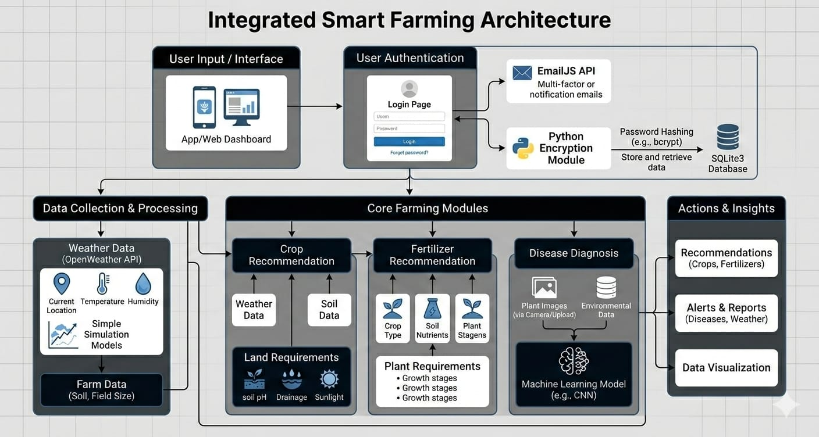

  - MODULES

- User Interface Module: HTML5, CSS3, JavaScript.
- User Authentication Module: EmailJS API, Flask-Login, Bcrypt.
- Crop Prediction Module: OpenWeather API, Scikit-learn,
Random Forest.
- Disease Prediction Module: Color-Based Image Analysis,
Pixel Thresholding Heuristic.
- Fertilizer Recommendation Module: Random forest.
- Crop Growth Simulation Module: Logistic Growth Model, Rule-Based Growth Model.

- User Interface Module:
The User Interface Module is developed using HTML5, CSS3, and JavaScript to provide an interactive and responsive frontend for users. It manages page rendering, navigation, and form submissions for crop, fertilizer, and disease prediction services. This module uses client-side validation techniques based on conditional logic to ensure proper input formatting before sending data to the backend. It improves user experience by reducing invalid submissions and providing real-time feedback, but it does not use any machine learning algorithms.
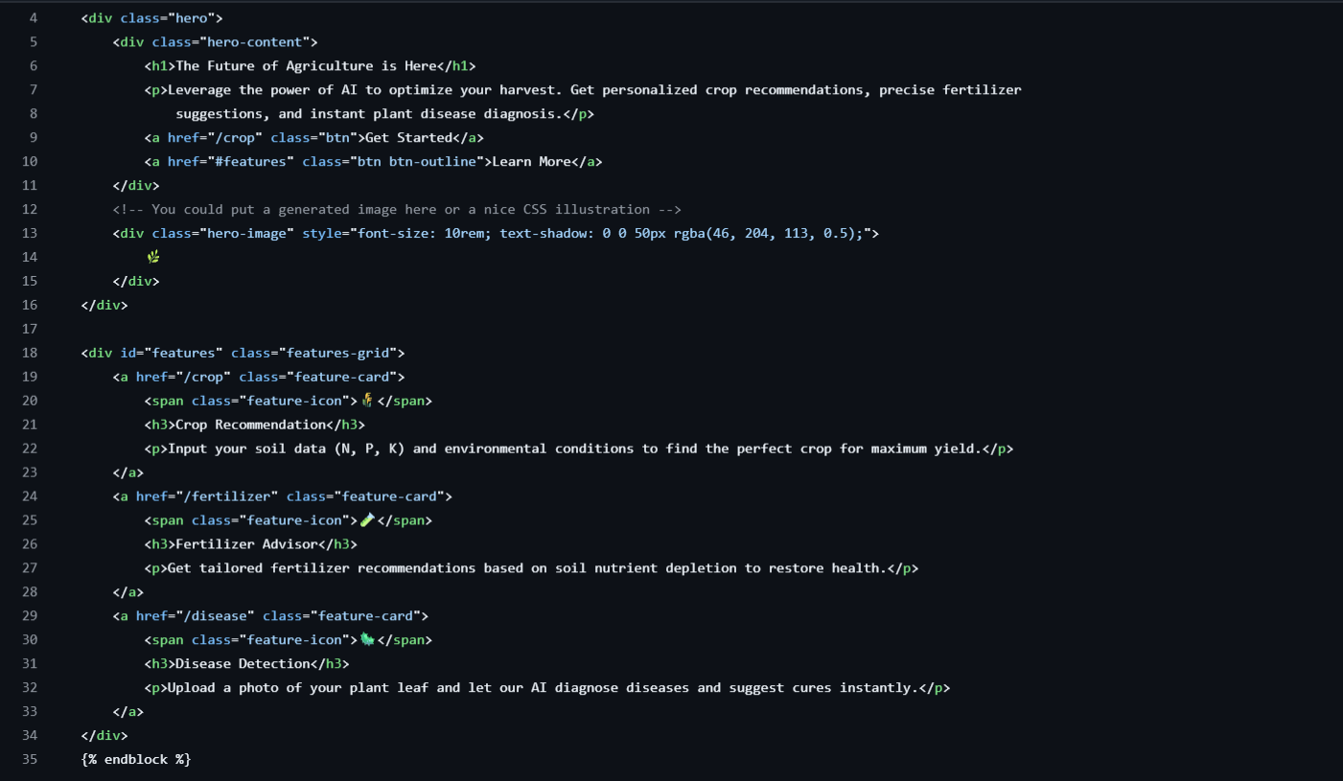
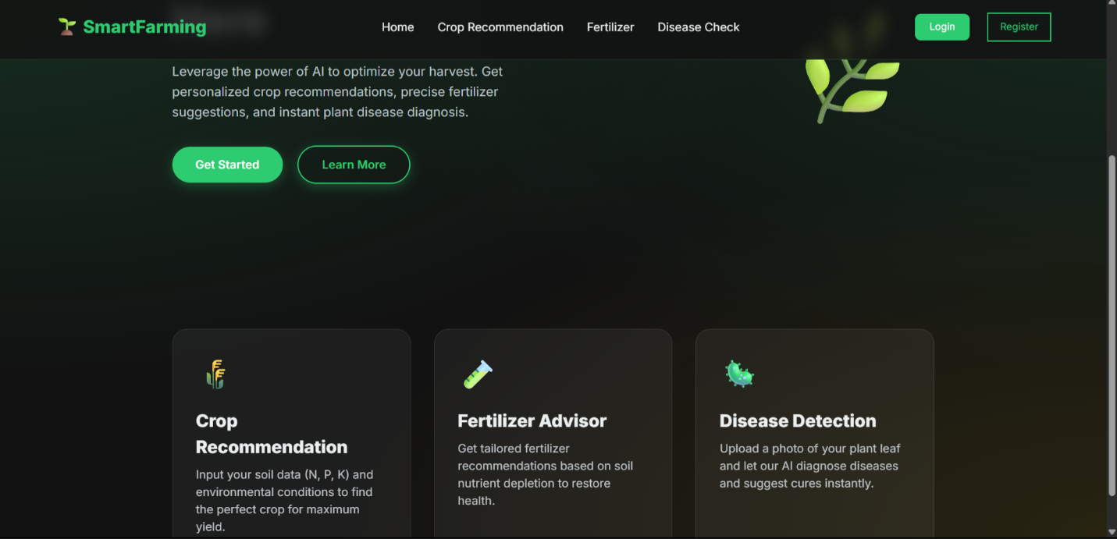

- User Authentication Module:
The User Authentication Module ensures secure user registration and login functionality. Passwords are encrypted using the bcrypt hashing algorithm with salting, providing strong protection against unauthorized access. Email verification is implemented using a six-digit randomly generated code with time-based expiration logic. Flask-Login manages session handling and user authentication states. This module relies on cryptographic hashing and conditional verification logic rather than machine learning, ensuring secure storage, validation, and controlled access to system features.
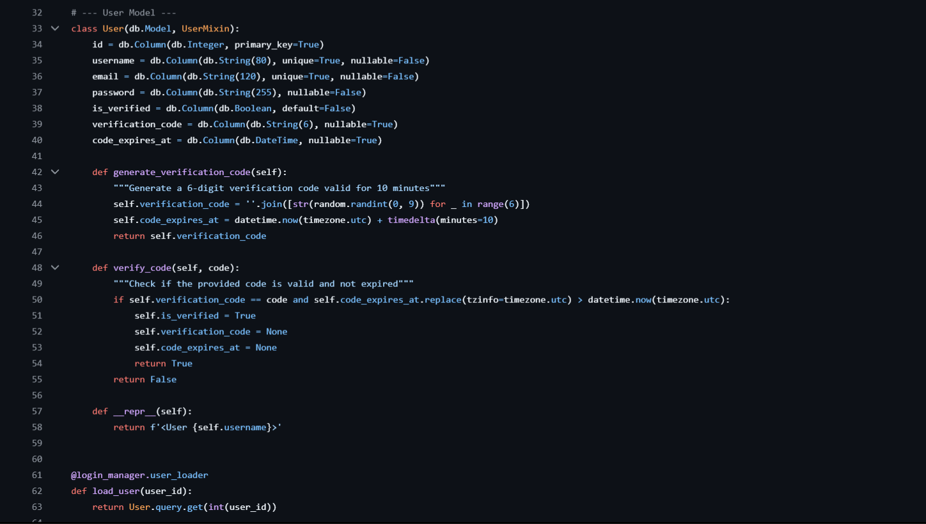


- Crop Prediction Module:
The Crop Prediction Module uses a Random Forest classification algorithm from Scikit-learn to recommend suitable crops. It is a supervised machine learning model trained on soil nutrients (N, P, K), temperature, humidity, pH, and rainfall data. Weather information can be integrated from the OpenWeather API to enhance prediction accuracy. The Random Forest model combines multiple decision trees to improve generalization and reliability. It predicts the top three crops with probability scores based on environmental conditions.
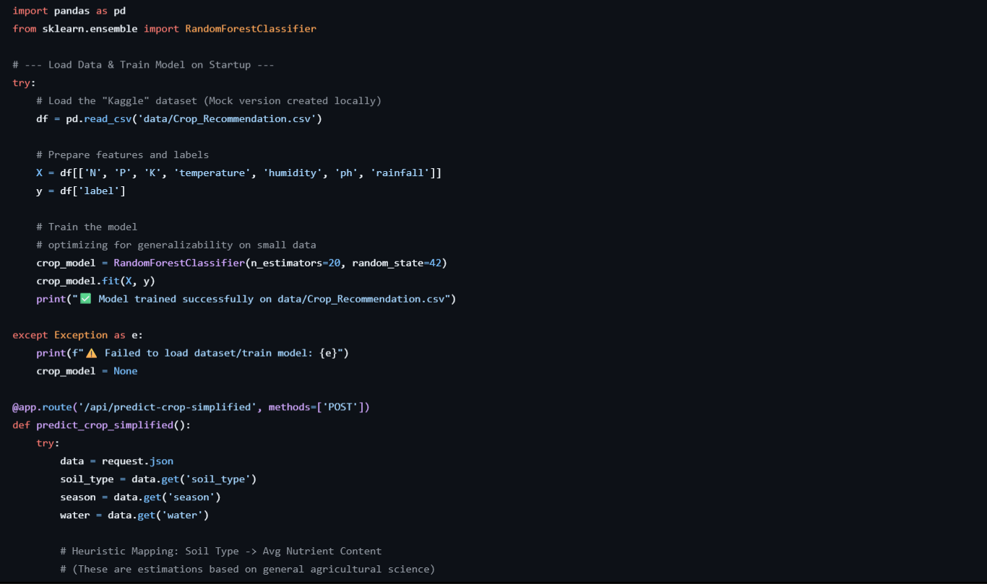
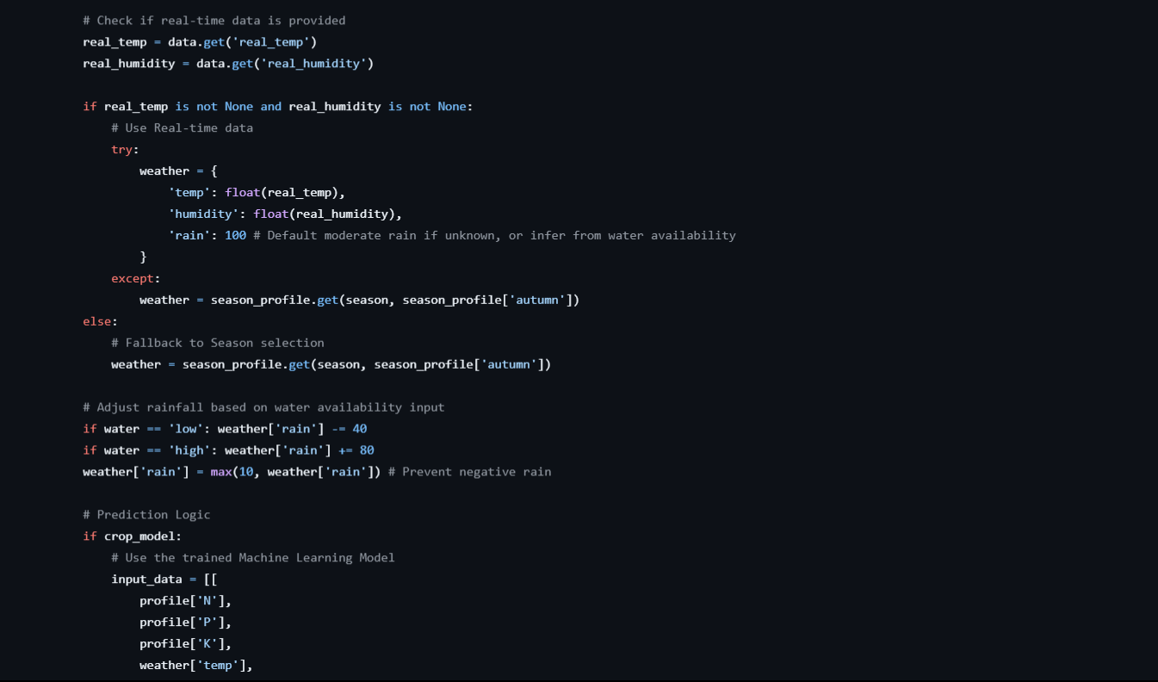
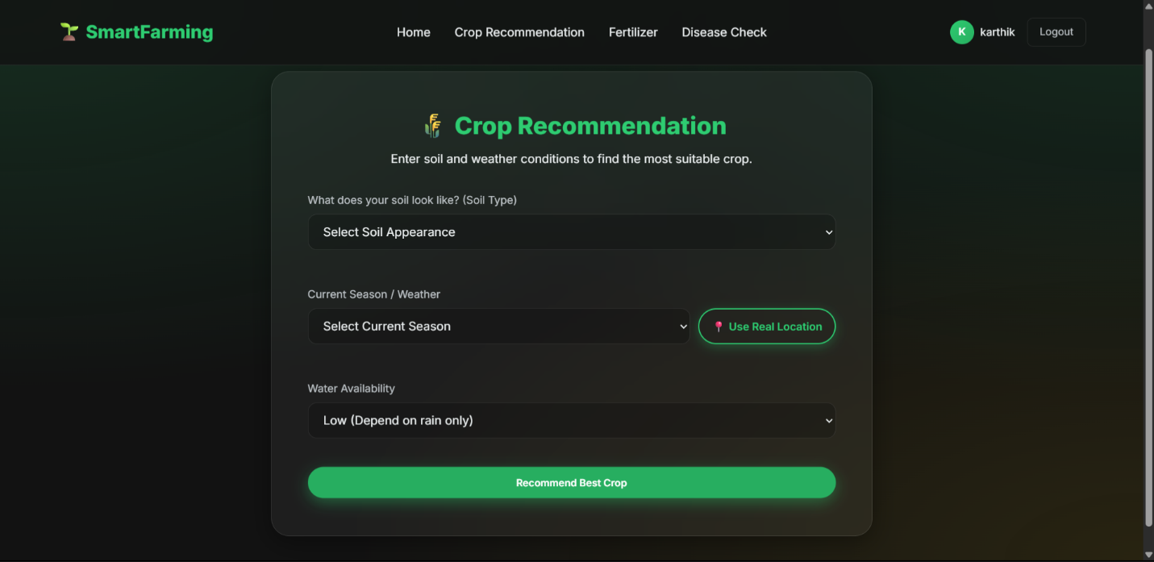

- Disease Prediction Module:
The Disease Prediction Module uses rule-based computer vision techniques instead of deep learning. It analyzes uploaded leaf images using RGB color ratio analysis and pixel thresholding methods. The system counts green pixels to detect healthy leaves and identifies brown or yellow pixels to detect disease symptoms. Based on predefined ratio thresholds, it classifies plant health conditions. This heuristic-based approach provides fast predictions without using convolutional neural networks or advanced deep learning models.
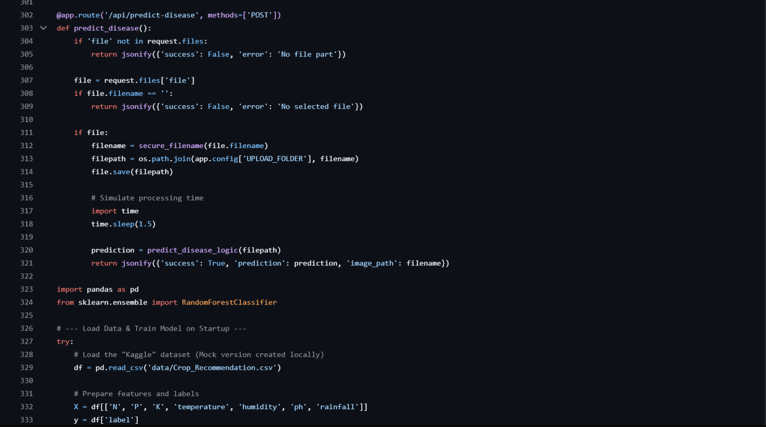
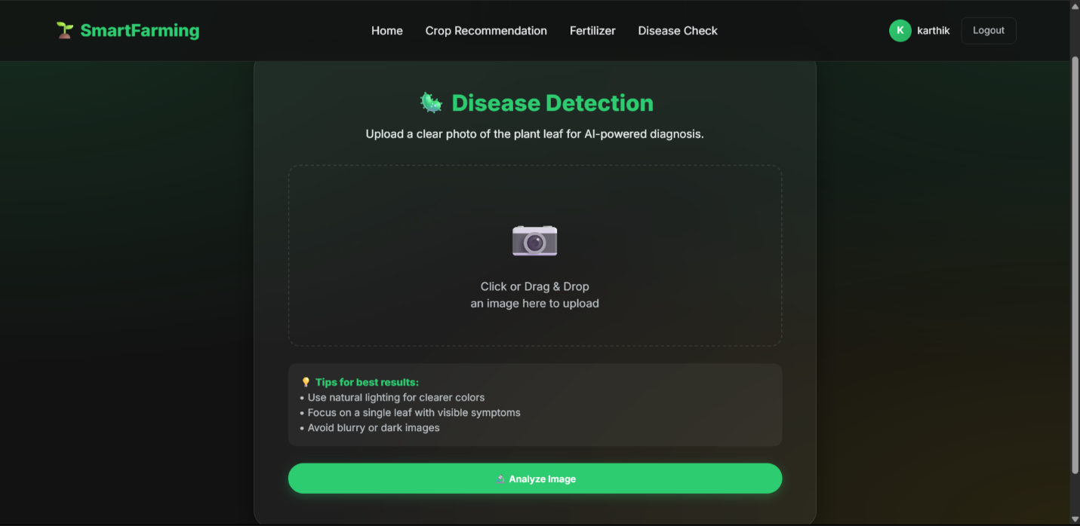
- Fertilizer Recommendation Module:
The Fertilizer Recommendation Module applies a Random Forest classification algorithm to suggest suitable fertilizers. It is trained using encoded categorical inputs such as crop type, soil type, and observed symptoms. After prediction, heuristic dosage rules calculate the required fertilizer quantity based on land size and measurement units. The system also performs unit conversions to ensure accurate recommendations. This module combines supervised machine learning with rule-based quantity estimation for practical agricultural decision support.
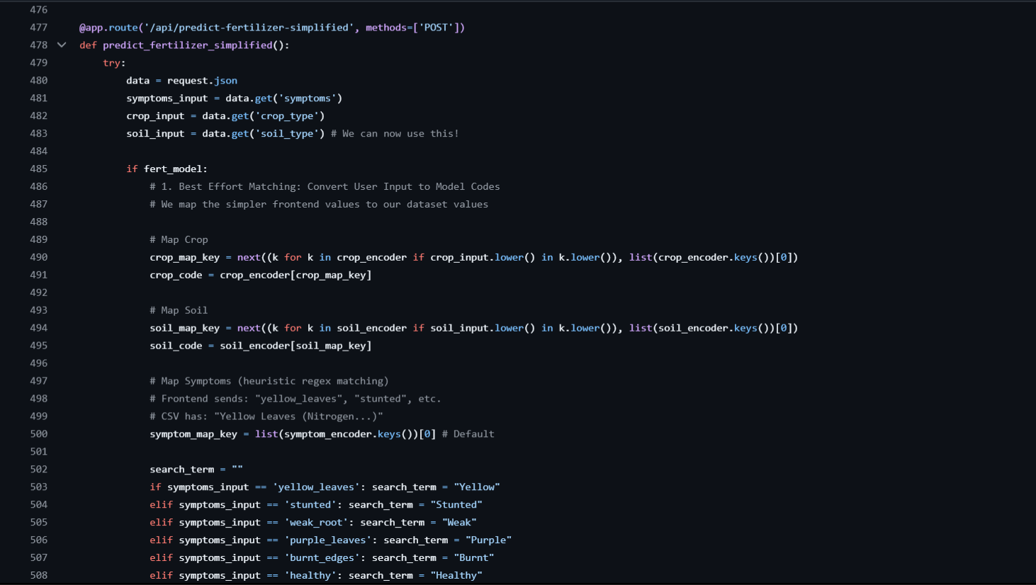
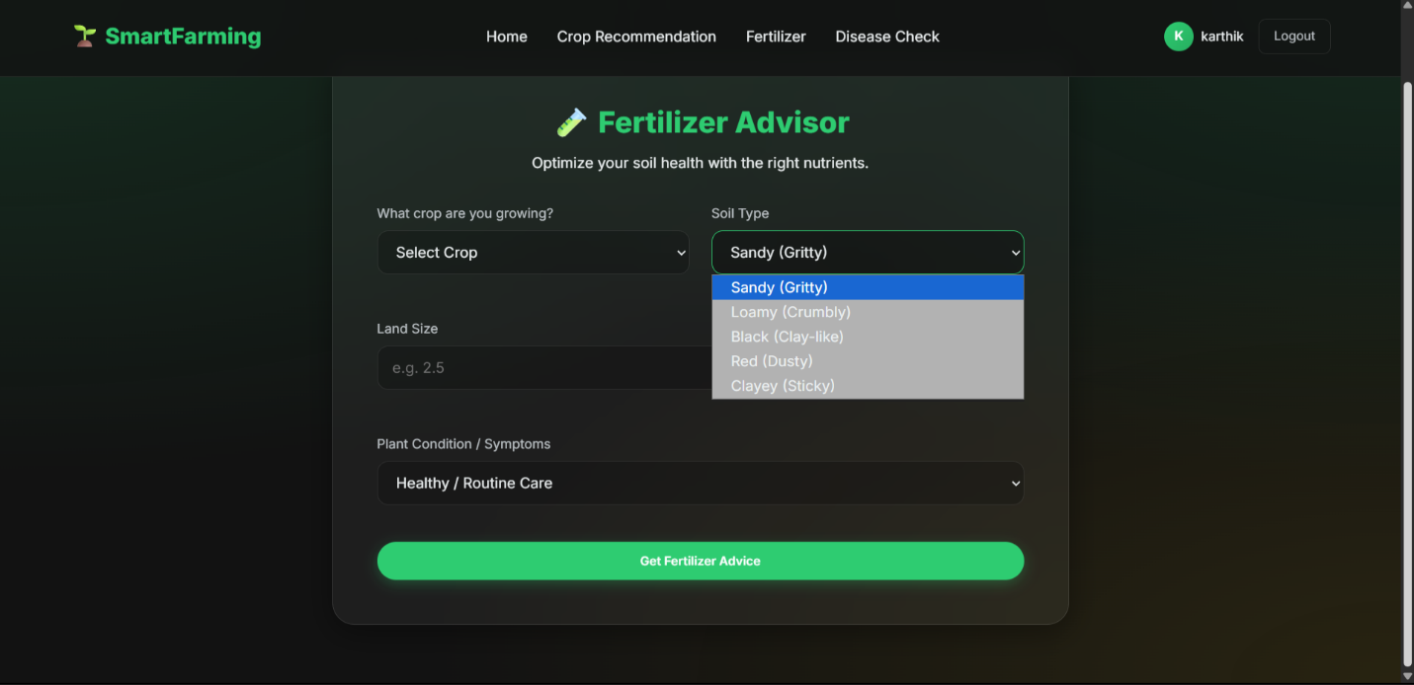
- Crop Growth Simulation Module:
The Crop Growth Simulation Module models plant development using rule-based environmental logic. It simulates growth stages such as germination, vegetative growth, flowering, and harvesting based on soil nutrients, temperature, water availability, and fertilizer input. A deterministic weighted scoring system estimates growth rate and overall crop health. The module uses conditional rules and environmental thresholds to predict growth performance over time. It does not use machine learning unless an additional predictive model is integrated for yield estimation.

